UiPath Investment Request Template
The purpose of this template is to provide partners interested in applying for UiPath proposal-based joint investment funds with a key understanding of what is expected to have a successful outcome for their proposal pitch.

Proposal Guidelines

- Please review the UiPath $20M Investment Funds Program Guide for complete terms and conditions.
- We recommend working with your Partner Account Manager, Alliance Manager and/or Partner Marketing Manager to maximize your proposal potential for approval.
- The UiPath Review Board will meet Nov 8, 15, Dec 6 and 13, 2018, additional dates may be offered in 2019.

Application Process
- Together with your partner or alliance management team, develop a business investment plan proposal using the UiPath Investment Request Template.
- Submit the plan to partners@uipath.com. All submissions will be treated with UiPath and partner confidentiality unless written permission is granted.
- Be ready to pitch your idea to the UiPath Partner Review Board for each fund.

Proposal review and “pitch” sessions will be held on the following dates:
- November 8, 2018
- November 15, 2018
- December 6, 2018
- December 13, 2018

Additional sessions may be scheduled in 2019

Any questions, email partners@uipath.com

Tell Us About You
Partner Profile
Partner Company Name*
Partner Company Address*
State/Province, Zip, Country*
Type of Partnership with UiPath
(Business/Technical)
Company Annual Revenue
Total Number of Employees
Total Number of Customers
Partner Contacts
Primary Contact Name
Primary Contact Email
Executive Name
Executive Title
Executive Email
Other Team Members that will contribute to this plan. (Add rows as required)
Name
Title/Role
Email
UiPath Contacts
Partner Manager Email
Partner Success Manager Email
Marketing Partner Manager Email
Other Team Members that will contribute to this plan. (Add rows as required)
Other – Required for Venture Innovation Fund Proposals
Technology Category
(AI, BPM, Content, OCR, NLP, Chatbot, etc.)
Vertical focus if any
System Integration Partners
(name top three)
# of UiPath certifications
Completed by Developer - Required for Venture Innovation Fund Proposals
Date of Request
Technology Solution Category
(AI, BPM, Content, OCR, NLP, Chatbot, etc.)
Developer Name
Developer Email
# of years development experience
# of projects/products developed
RPA Practice / Business Resources – Recommended for Acceleration Fund Proposals
Top RPA Solutions
Year RPA Practice Founded
RPA Practice Revenue
# of Years with UiPath RPA
# of RPA Customers
# of UiPath RPA Customers
# of RPA Deployments
# of UiPath RPA Deployments
# of RPA Developers
Where are developers located?
# of RPA Solution Architects
# of RPA Implementation Engineers
# of RPA Infrastructure Engineers
# of RPA Business Analysts

Tell Us About Your Idea
Overview*
[Delete this text] Use this space to describe at a high level why you are recommending UiPath to approve your proposal. What are you trying to accomplish? Is it innovative or unique? How does it align to UiPath goals? What is the impact / value that this investment will bring? No text limit.

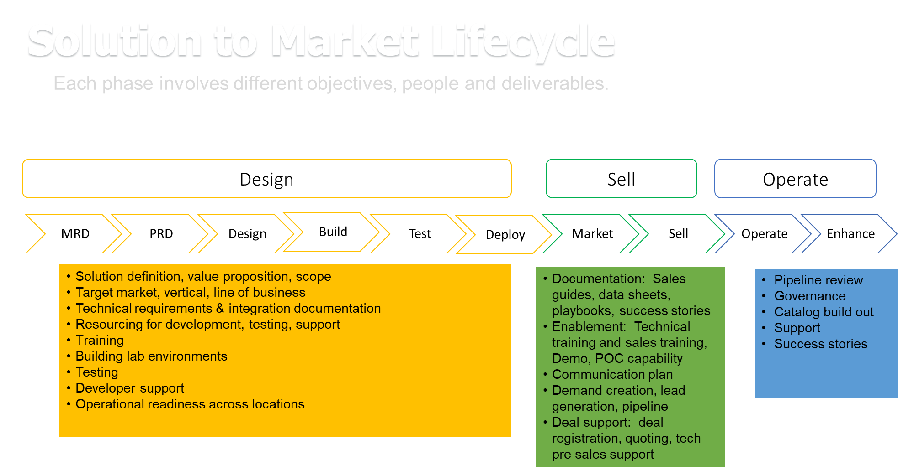
Solution to Market Lifecycle
- [Delete this text] Referencing the graphic above, does your proposal address one or more areas of a solution lifecycle to ensure an optimal outcome for the investment? Describe the Design, Sell and Operate components that will be included in your investment plan. Please describe the strength of the product/solution if it is a technology innovation idea utilizing Venture Innovation Fund. No text limit.

Detailed Scope of Needs/Requirements from Uipath*
- [Delete this text] Provide a specific description of what is being requested from UiPath. Include milestones, timelines if appropriate.

Details of Partner Contribution*
- [Delete this text] Provide a specific description of what you are providing in support of this investment. Include milestones, timelines if appropriate.

Relevant Expertise and Experience*
- [Delete this text] Describe your company's expertise and experience that helps us understand how you will be successful with this initiative. Include previous experience, partnerships with other organizations, proven early traction and execution (PoC, client interest, etc.), how this idea supports the long-term vision of your company and any other information that may be relevant as your proposal is reviewed.

Investment Measurement*
- [Delete this text] Describe the key performance indicators (KPI) and how this investment will be measured, please include timelines for results.

